Functions and Graphs - Questions
June 2017 Mathematics Advanced Paper 1: Pure Mathematics 3

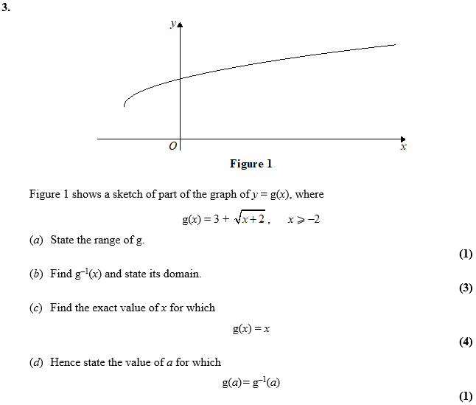

June 2016 Mathematics Advanced Paper 1: Pure Mathematics 3

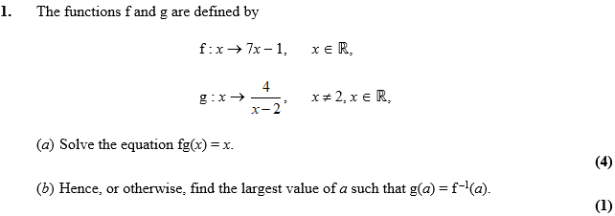

June 2015 Mathematics Advanced Paper 1: Pure Mathematics 3

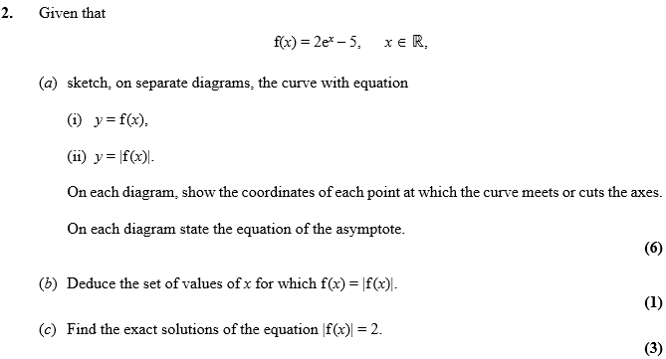

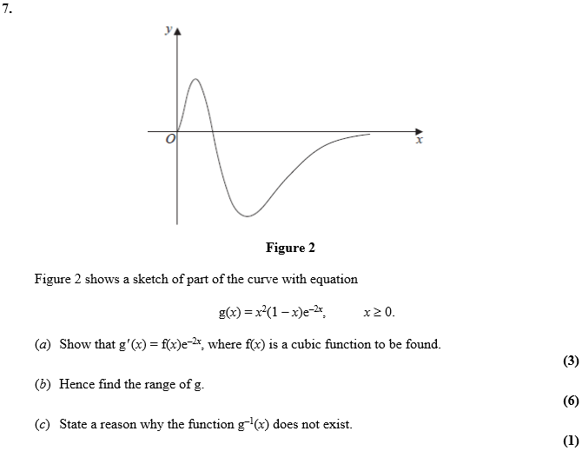

June 2014 Mathematics Advanced Paper 1: Pure Mathematics 3

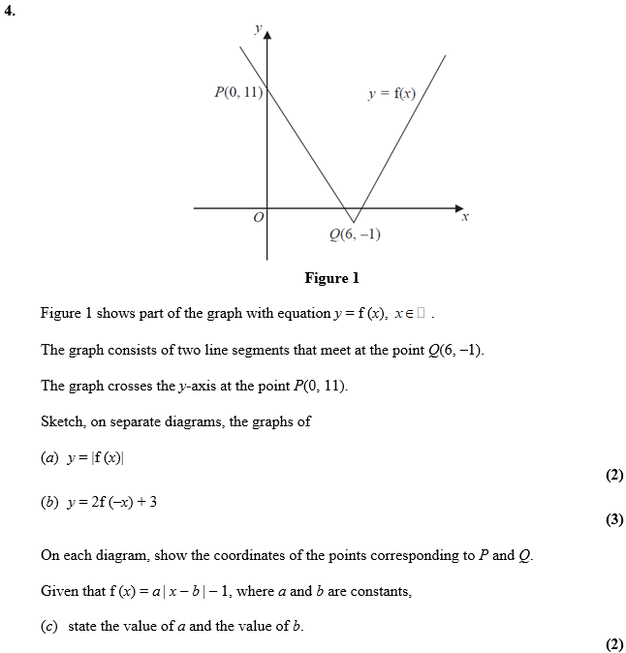

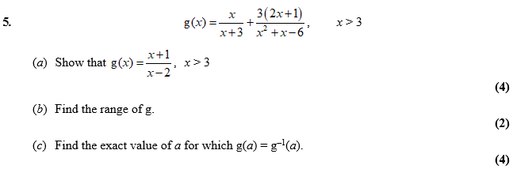

June 2013 Mathematics Advanced Paper 1: Pure Mathematics 3

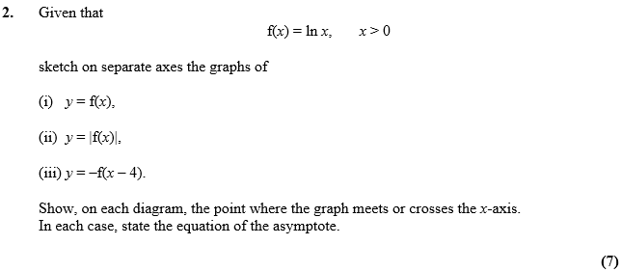

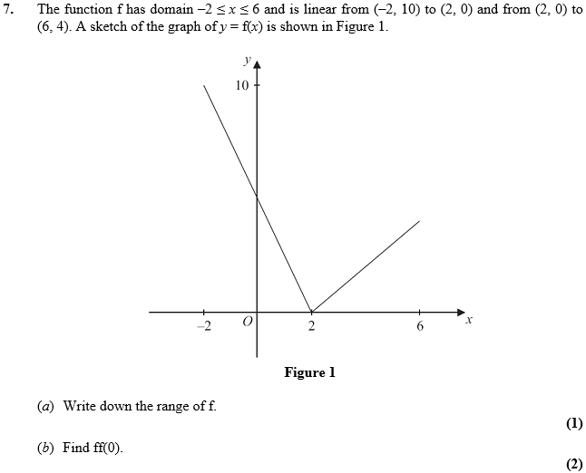
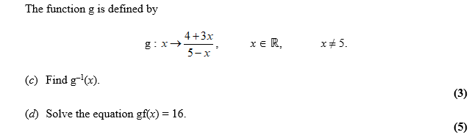

Jan 2013 Mathematics Advanced Paper 1: Pure Mathematics 3

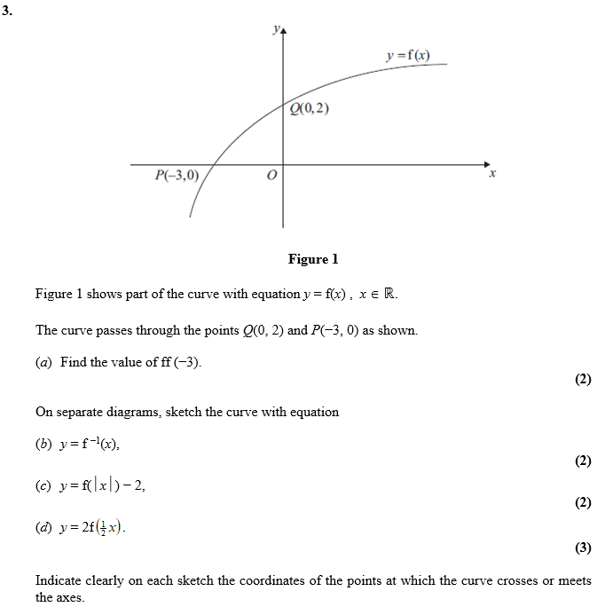

June 2012 Mathematics Advanced Paper 1: Pure Mathematics 3

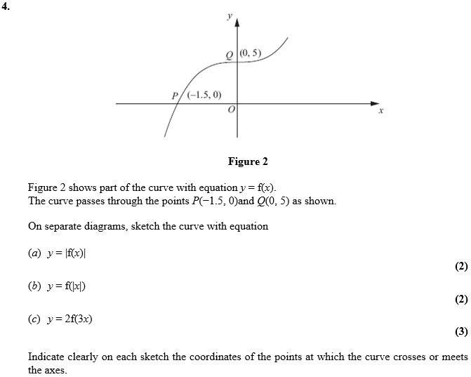

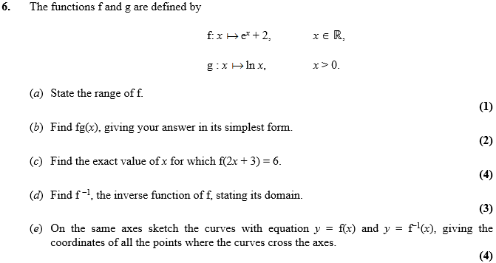

Jan 2012 Mathematics Advanced Paper 1: Pure Mathematics 3

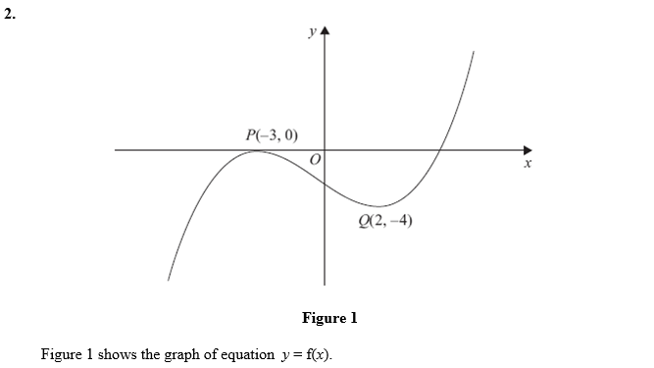
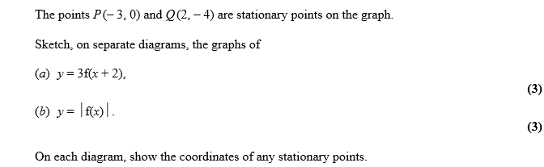

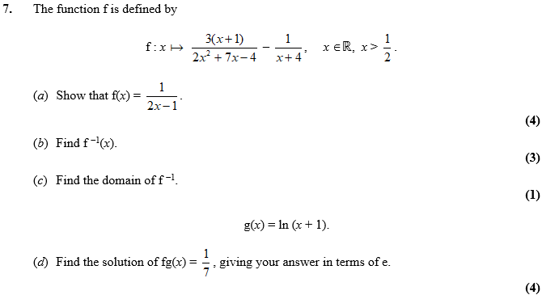

June 2011 Mathematics Advanced Paper 1: Pure Mathematics 3

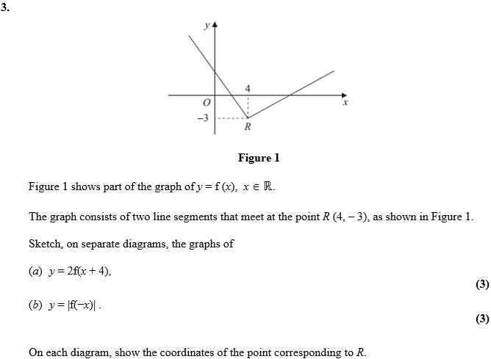

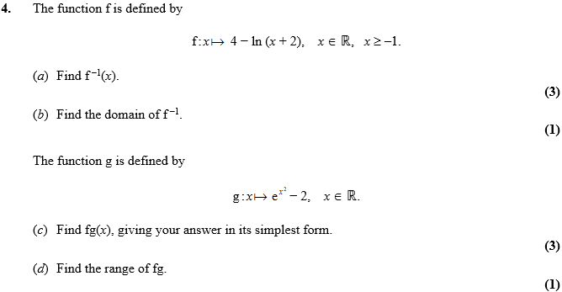
Jan 2011 Mathematics Advanced Paper 1: Pure Mathematics 3

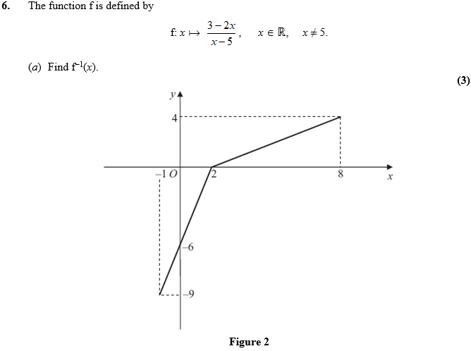
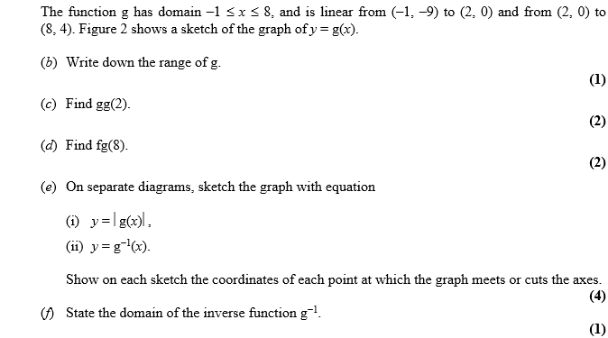
June 2010 Mathematics Advanced Paper 1: Pure Mathematics 3

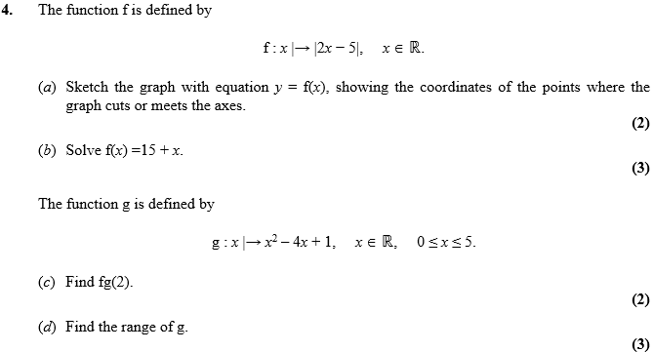

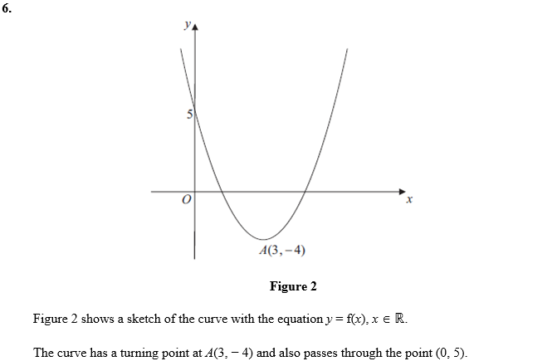
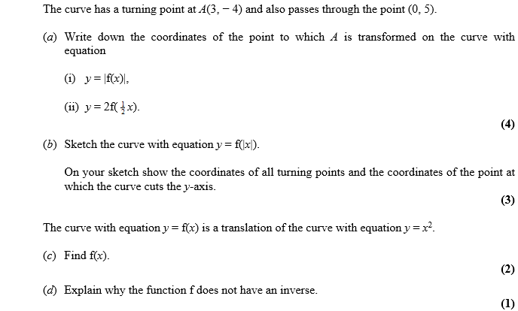

Jan 2010 Mathematics Advanced Paper 1: Pure Mathematics 3

